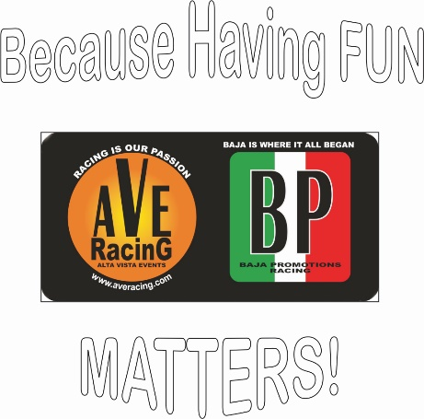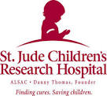
St. Jude Children's Research Hospital
“RACING & RAISING PROJECT”

FOR IMMEDIATE PRESS RELEASE…

Sunday, November 18, 2018 – California City, CA – AVE/BP Racing released it’s ambitious 2019 event schedule, which features a number of very interesting and innovative ideas.

However, the most unique and creative idea for 2019 is the effort that Mr. and Mrs. Peralta have been working on: That is to set up a Charity mechanism called The St. Jude Children’s Research Hospital “Racing & Raising Project.”

AVE/BP Racing is putting the charity project in motion by pledging to donate $5.00 out of every entry in the 2019 PURE UTV OFF-ROAD DEZERT SERIES. The seven-event series will take place at Alta Vista Ranch, California City-Proper, CA. It’s first event is Saturday, January 26, 2019.

The “Racing & Raising Project” will have a special box dedicated to it on the entry forms where racers can donate to the same cause during the year. Any amount is welcomed.
In addition, a tally will be kept of all those who donate to St. Jude’s during the year, which will be sorted alphabetically and at the end of the year will be published.
There will also be a separate form that any non-racer, whether, family, friend, sponsors or supporter can use to donate on behalf of the Racer & Navigator on the entry.

Now for the biggest news: After the last event of the season (November 2019), when AVE/BP Racing crowns the PURE UTV 2019 CHAMPION DRIVER & NAVIGATOR, the entire Fund will be donated to St. Jude’s on behalf of the Champions and all the people who contributed towards the fund during the year. All donations are tax deductible.

Lois Peralta, VP and Race Manager of AVE/BP Racing stated, “We hope to encourage many of the participants to donate during the course of the year in order to build up the Fund. It is important that our community be involved because it is such a great and worthy cause. Plus, Pure UTV Off Road Racing is acknowledged not only as a family sport but as a sport the cares about people, children and their families.”

Lou Peralta, race organizer, added; “Saint Jude Children's Research Hospital is perhaps the leading medical hospital in the world that takes care of the young, never charging for any of their services, which includes housing for their parents or guardians while the child is in the hospital. St. Jude is truly a magnificent organization and it needs all the support from our off-road friends.”

Please note: “The mission of St. Jude Children’s Research Hospital is to advance cures, and means of prevention, for pediatric catastrophic diseases through research and treatment. Consistent with the vision of its founder Danny Thomas, no child is denied treatment based on race, religion or a family's ability to pay.”

Look for the special box in every AVE/BP Racing entry form with the St. Jude logo and also a separate form for crew members, families and supporters, during the exciting 2019 event season.

For more details, please visit: www.averacing.com or send queries or request for the forms to: info@averacing.com

# # # #

